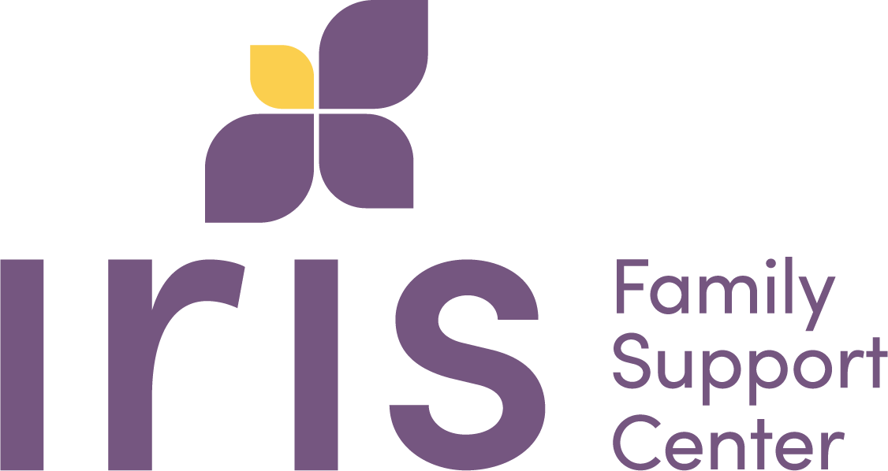

GOAL/TREATMENT PLAN
Case Name:

Goal #1: Each participant will engage in, at least, 12 sessions of the therapeutic skills group.

Goal #2 Each participant will learn, practice and instill one therapeutic skill concerning mental health per week.

_______________________ __________________
Client Printed Name Staff Printed Name

_____________________ _______________________
Client Signature and Date Staff Signature and Date



